MY STONE TOOLS
AND INTERESTING FACTS ABOUT THEM
My first tool is an arrowhead and it was used for hunting. When my tool was used in the past they would use rocks to make the tools. They used a smooth rock and a hard rock but first they would have to find a soft rock in order to make the tool they were going to make it. My class tried to make some tools with clay and it was hard because it would get dry fast and it would brake easy.
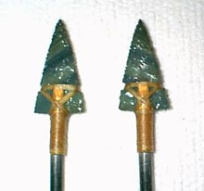

My second tool is a stone knife it would be used for carving and skinning animal skin. When they used my tool for carving they would use the round curving part of it to cut wood. When they used the other side of the knife it would be used for skinning animal skin because it would be harder and it’s harder because of how tough it is. I do think it would be easy to use.
